Pacific Rim Laser Damage 2025

Title of your presentation

Ichiro Suzuki*ª, Nakata Hide^{b}, Shohei Ohtaniª, and Kaoru Mitomaª
ªNation’s Laser Research Laboratory, Tokyo, 1828585 Japan;
^{b}Dept. of High quality Optics, Kawasaki 2140012 Japan

Abstract – This electronic document serves as a template for the Pacific Rim Laser Damage Conference 2025. A one-page summary should be prepared following these guidelines: (1) Use 12-point Times New Roman font for the main text; smaller fonts may be used for figure captions. (2) Color figures are accepted. (3) A few keywords should be listed immediately after the abstract section. (4) References should be included at the end of the document.
After completing the manuscript, it is strongly recommended to convert the file to PDF format before submission.

Keywords: High damage threshold, Damage test, UV lasers

1. Introduction
This template file provides an example format for your manuscript. Minor customization is allowed. The manuscript will be included in the conference’s electronic proceedings, serving as a reference for attendees.

Other elements — such as figure caption format, table layout, and figure size — may be freely formatted, as long as the total content fits within one A4 page.

The main text should be written in clear and correct English to ensure it is easily understood by conference participants. Spell-check and grammar-check tools are highly recommended before submission.

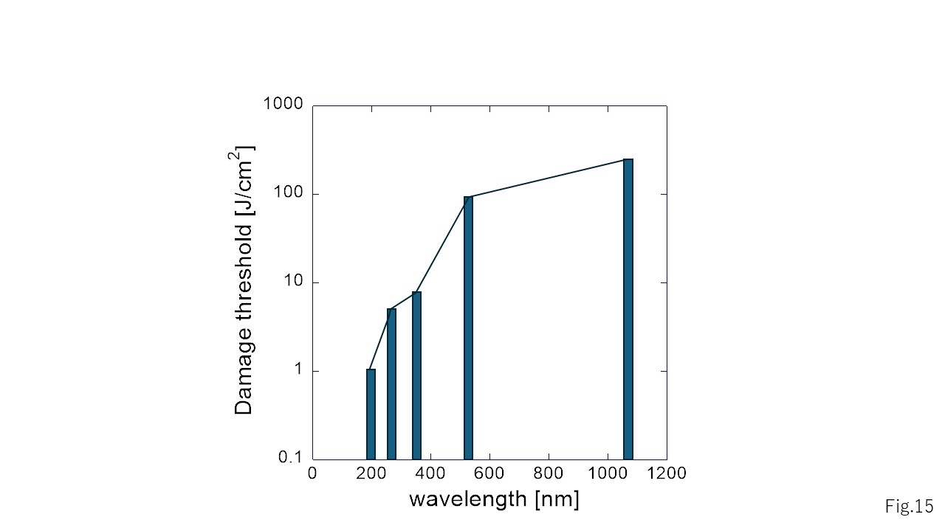
If you include figures in your manuscript, please ensure that the font size within the figures is similar to that of the main text for visual consistency.
Fig. 1: Figure captions should be placed below each figure.

2. Summary
As in standard journal manuscripts, references and acknowledgments should appear at the end of the document.

References
[1] C.R. Clemmer, T.P. Beebe Jr., Science 251 (1991) 640
[2] J. Xhie, K. Sattler, M. Ge, N. Venkateswaran, Phys. Rev. B 47 (1993) 15835

